DOCUMENTATION

ABSTRACT
The Faculty Course Allotment Order System is a
simple software application developed using the
C programming language to automate the
process of allocating courses to faculty members in an educational institution. The system assigns courses based on the maximum workload
capacity of each faculty member.
INTRODUCTION
In educational institutions, allocating courses to faculty members is an important administrative task. Traditionally, this process is carried out manually, which may lead to errors, workload imbalance, and time consumption. To overcome these issues, a Faculty Course Allotment Order System is developed.
SOFTWARE REQUIREMENTS
Operating System: Windows / Linux
· Programming Language:C
· Compiler: GCC/Turbo C/Dev-C++
• Text Editor or IDE: Code::Blocks/VS Code/Dev-c++
HARDWARE REQUIREMENTS
Personal Computer /Laptop
• Minimum 2GB RAM
· Intel / AMD Processor
CODE
#include <stdio.h>
#include <string.h>

#define MAX_FACULTY 5
#define MAX_COURSE 5

Struct Faculty {
Int id;
Char name[30];
Int maxLoad;
Int currentLoad;
};

Struct Course {
Int id;
Char name[30];
Int assigned; // 0 = not assigned, 1 = assigned
};

Int main() {
Struct Faculty f[MAX_FACULTY];
Struct Course c[MAX_COURSE];
Int I, j;

// Faculty details
Printf(“ENTER FACULTY DETAILS\n”);
For (I = 0; I < MAX_FACULTY; i++) {
F[i].id = I + 1;
Printf(“\nEnter name of Faculty %d: “, I + 1);
Scanf(“%s”, f[i].name);
Printf(“Enter max workload: “);
Scanf(“%d”, &f[i].maxLoad);
F[i].currentLoad = 0;
}

// Course details
Printf(“\nENTER COURSE DETAILS\n”);
For (I = 0; I < MAX_COURSE; i++) {
C[i].id = I + 1;
Printf(“\nEnter course name %d: “, I + 1);
Scanf(“%s”, c[i].name);
C[i].assigned = 0;
}

// Course allotment logic
Printf(“\nCOURSE ALLOTMENT\n”);
For (I = 0; I < MAX_COURSE; i++) {
For (j = 0; j < MAX_FACULTY; j++) {
If (f[j].currentLoad < f[j].maxLoad && c[i].assigned == 0) {
Printf(“Course %s allotted to Faculty %s\n”,
C[i].name, f[j].name);
F[j].currentLoad++;
C[i].assigned = 1;
Break; // stop after one allotment
}
}
If (c[i].assigned == 0) {
Printf(“Course %s could not be allotted\n”, c[i].name);
}
}

// Display final faculty load
Printf(“\nFINAL FACULTY LOAD\n”);
For (I = 0; I < MAX_FACULTY; i++) {
Printf(“Faculty %s -> Load: %d / %d\n”,
F[i].name, f[i].currentLoad, f[i].maxLoad);
}

Return 0;
}
RESULT
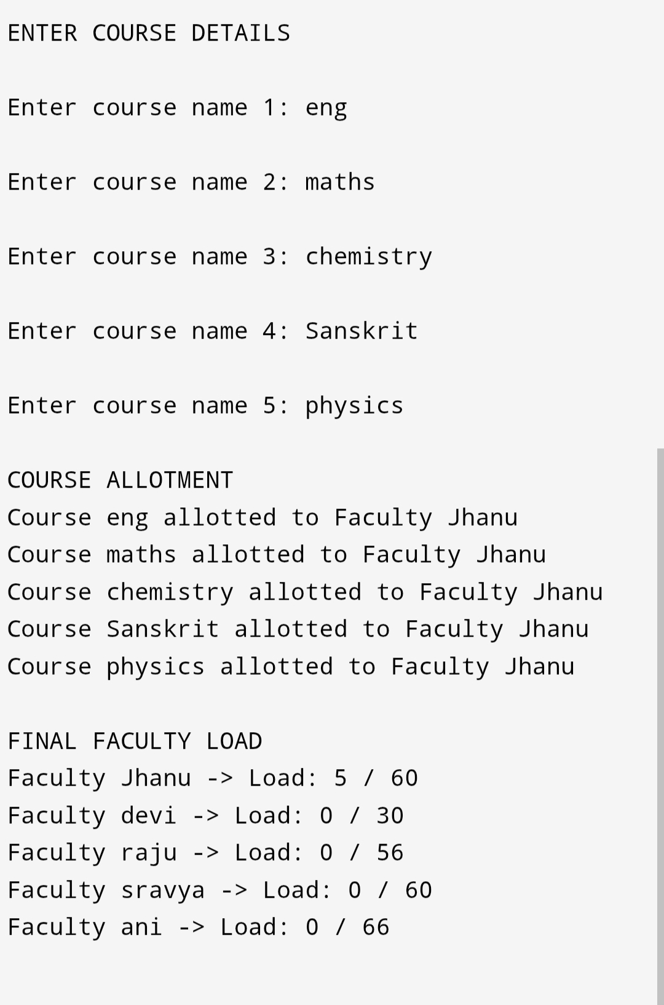
CONCLUSION
The Faculty Course Allotment Order project
Successfully demonstrates an efficient and
Systematic approach to assigning courses to
Faculty members based on predefined criteria
Such as faculty availability, maximum workload and course requirements. By automating the allotment process, the system minimizes manual errors, ensures fair distribution of workload, and improves transparency in academic planning.

